**3. Git-HOL**

* Construct a branch, do some changes in the branch, and merge it with master (or trunk)

**Steps:**

Create a new branch and List branch

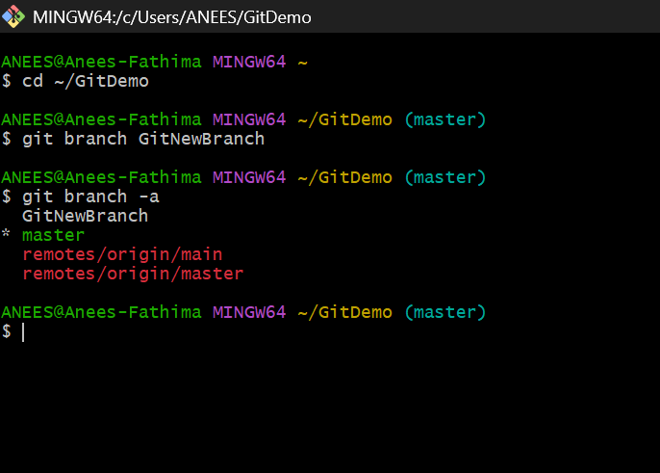

Switch branch



Add files

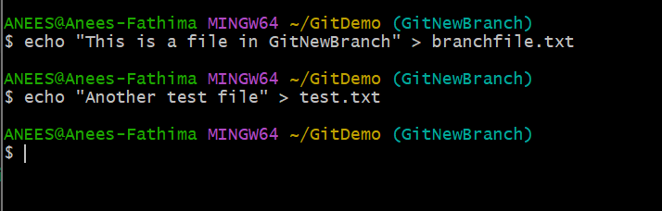

5. Commit changes

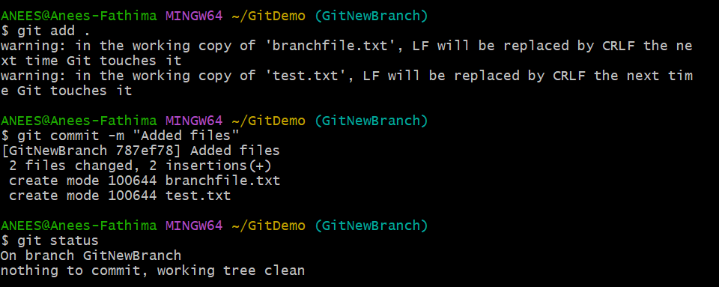

**Merging**

1. Switch to master

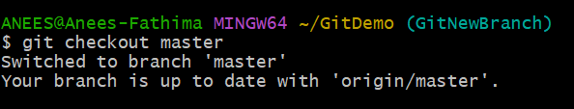

1. Show branch differences

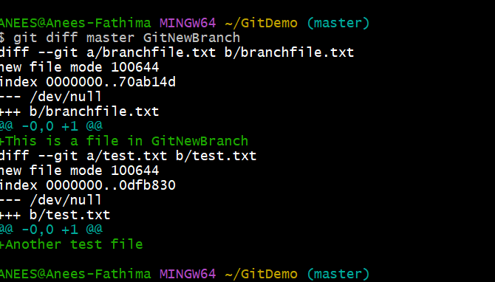

1. Merge branch into master

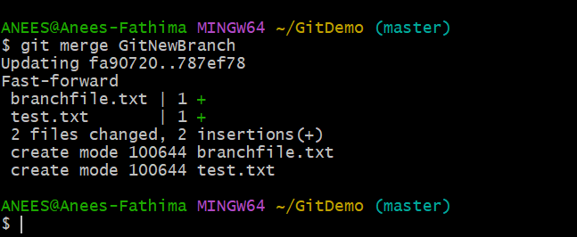

1. View merge history

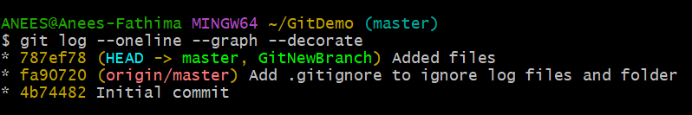

1. Delete merged branch

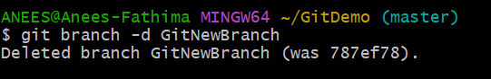

6.Final status check

